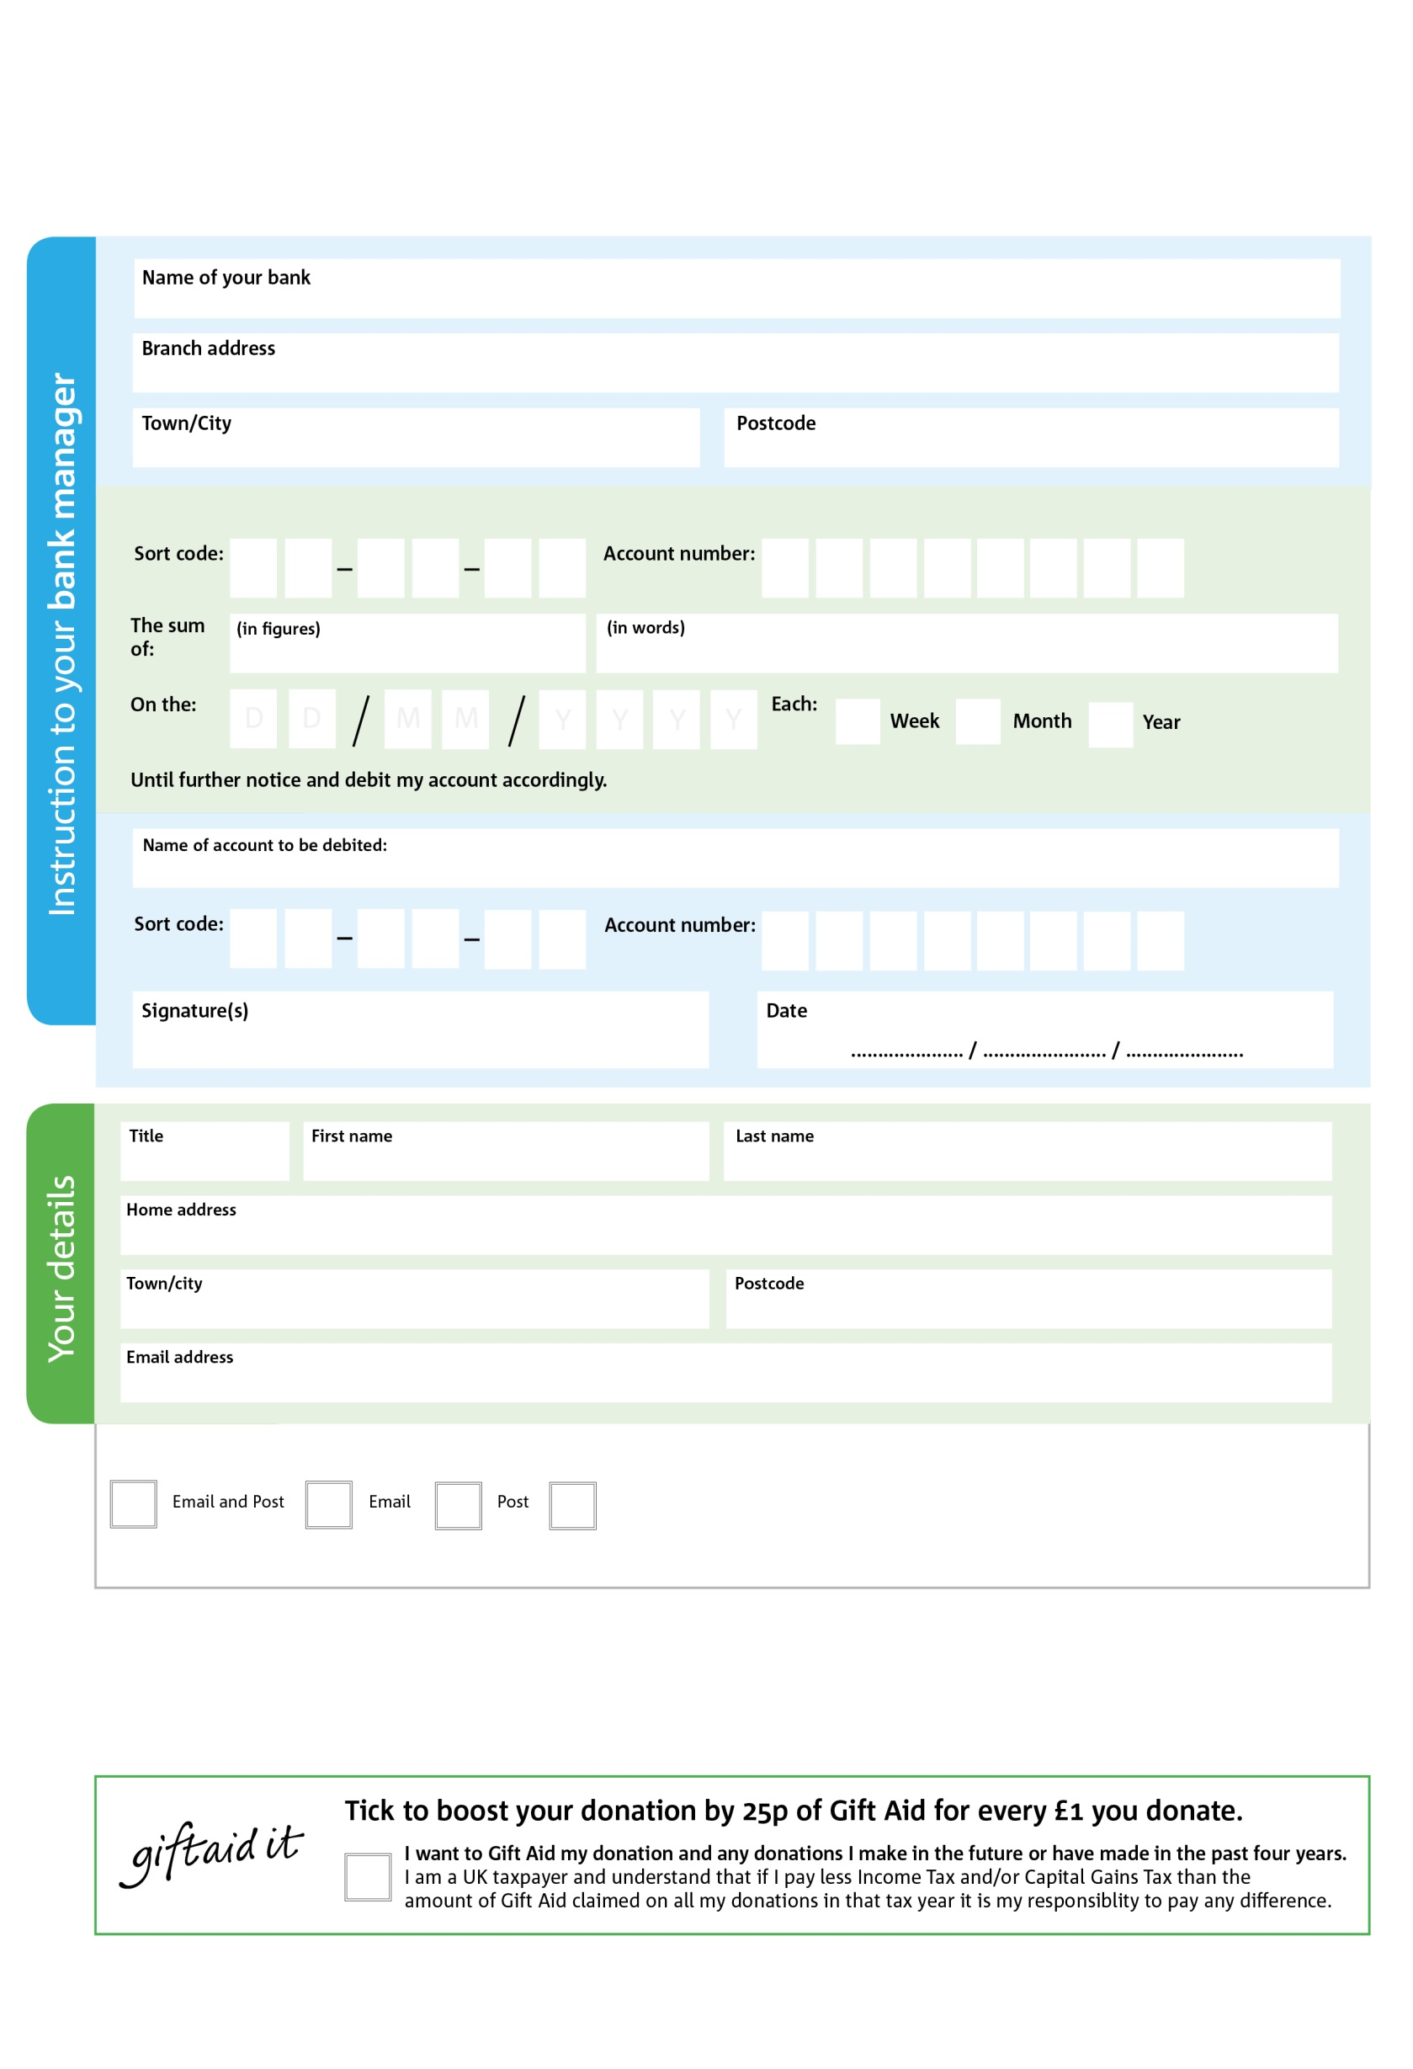

Reg. Charity No: 1152046 | Reg. in England & Wales

**Standing Order Mandate**

**www.hartlepool.foodbank.org.uk**

POSTAL ADDRESS: Hartlepool Foodbank, 28 Church Street, Hartlepool, TS24 7DH

0

V

6

V

4

V

5

V

8

V

6

V

4

V

4

V

**Please pass this form onto the foodbank, using the foodbank’s address at the bottom, who will save a copy for their records.   
They will then send it onto your named bank or building society.**

0

5

0

2

7

7

7

We would love to keep you up to date with information about Hartlepool Foodbank. Please tick your preference:

You can change your preferences any time by contacting us on 01429 598 404 or emailing us at info@hartlepool.foodbank.org.uk

I do not wish to receive future communications from Hartlepool Foodbank

Please pay Hartlepool Foodbank,

**Data protection**

*'Hartlepool Foodbank is committed to protecting your privacy and will process your personal data in accordance with current Data Protection legislation. Hartlepool Foodbank collects information to keep in touch with you and supply you with information relating to our work. To unsubscribe from our newsletter, send a message to the email address above with the word unsubscribe in the subject line. A full data privacy statement for financial donors is available from the foodbank on request.’*

You can change your preferences any time by contacting us on XXXXXXXXXXX or emailing us at XXXX@XXXXXXXXXX.foodbank.org.uk

I do not wish to receive future communications from XXXXXX Foodbank